**Course:** ENSF 337 – Fall 2020

**Lab #:** Lab 7

**Instructor:** M. Moussavi

**Student Name:** Quentin Jennings

**Lab Section:** B03

**Submission Date:** 2020-11-15

**Exercise A Memory Diagrams:**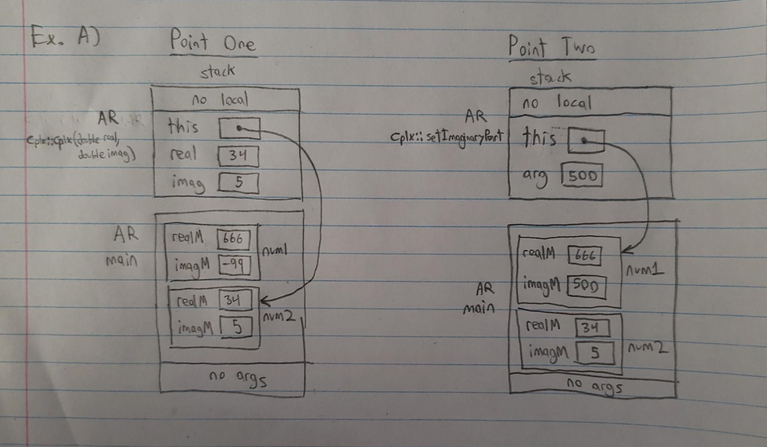

**Exercise C lab7Clock.h:**

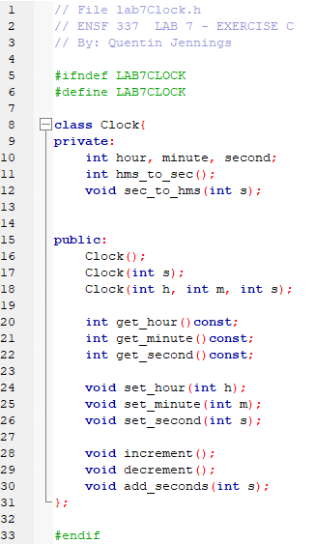

**Exercise C lab7Clock.cpp:**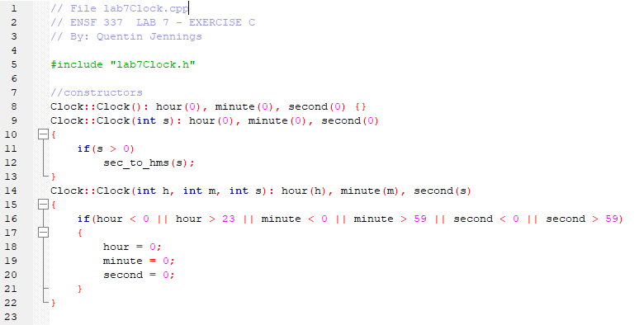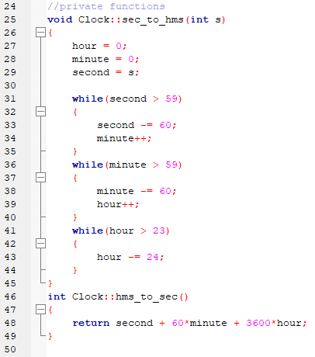

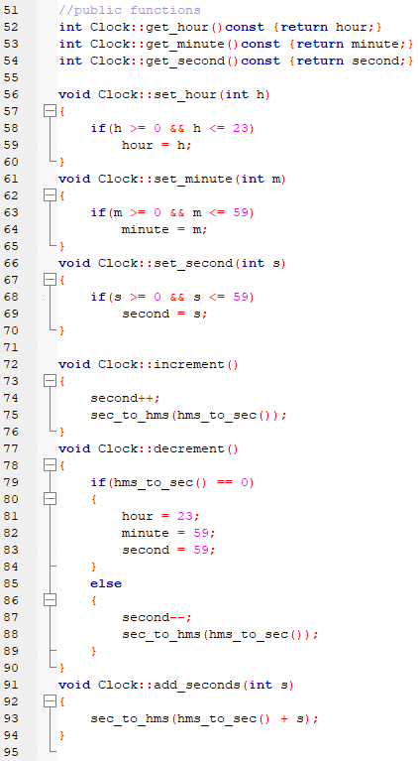

**Exercise C Output:**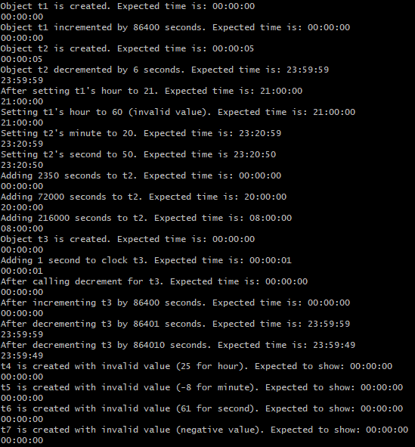

**Exercise D simpleVector.cpp:**

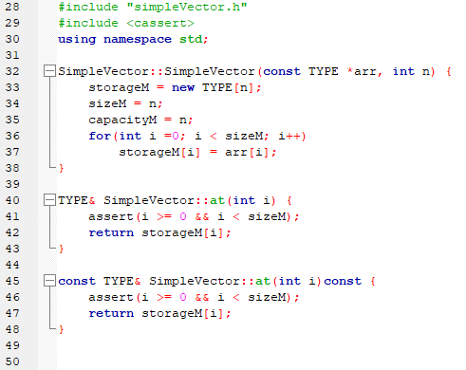

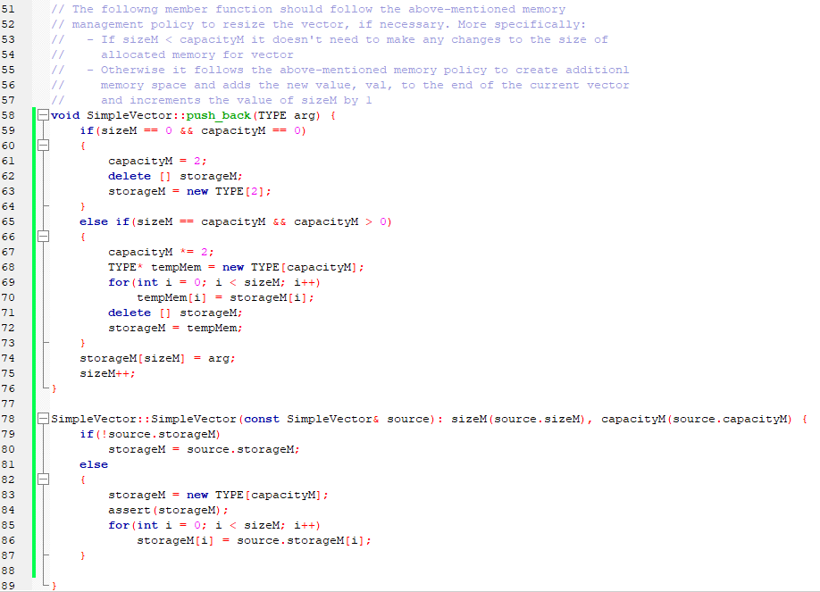

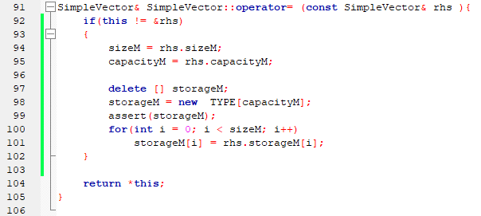

**Exercise D Output:**

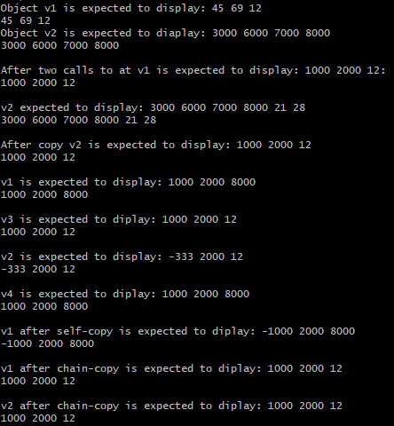

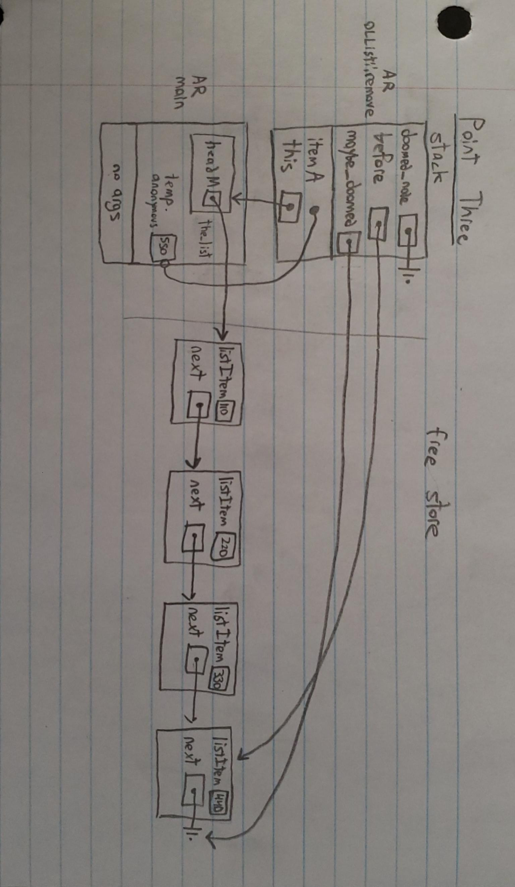**Exercise E Memory Diagrams:**